AWS Systems Manager helps you manage your EC2 instances and On-Premise systems at scale. You can easily get operations insights about the state of your infrastructure. It helps to detect instance issues easily and also it could be patching automation solution to enhance compliance. This article will provide high level plan to implement SSM monitoring for ON-PREM Windows servers. There are multiple SSM RUN documents created to monitor various services, files and certificates.

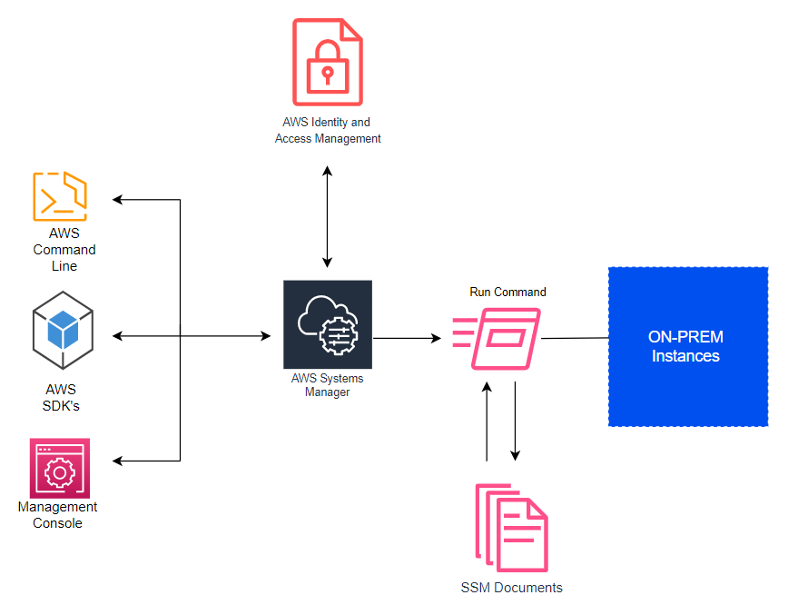

### Tagging standard: SSM Monitoring

We could try to leverage the existing tags for SSM monitoring.

|  |  |  |
| --- | --- | --- |
| Scope | Tags (Key: Value) | Description |
| All Hosts | Role: Host |  |
| PROD VM | Role: Production VM | SSM: Prod |
| SQL Standard | SQL Version: Standard |  |
| SQL Express | SQL Version: Express |  |
| All | SSM: Prod  SSM: Staged  SSM: Dev |  |

## How it Works ?

AWS Systems Manager is agent based solution where you need to install the SSM agent on the EC2, On-premise servers or virtual machines. Systems Manager agents makes it possible for Systems Manager to update, manage, and configure these resources effectively. The agent processes requests from the Systems Manager service in the AWS Cloud, and then runs them as specified in the request. SSM Agent then sends status and execution information back to the Systems Manager service by using the Amazon Message Delivery Service.

**Monitoring Type: File Size (SSM Document Name #1)**

|  |
| --- |
| **Integration** |
| ApplicationServer File Size Alert > 8GB |
| ApplicationServer File Size Alert > 13GB |
| GSL - LDF Monitor - ApplicationServer LDF Less Than 500MB - SQL Express |
| GSL - LDF Monitor - DataCollector LDF Less Than 500MB - SQL Express |
| GSL - LDF Monitor - LocationServer LDF Less Than 500MB - SQL Express |
| GSL - LDF Monitor - ApplicationServer LDF Less Than 1GB - SQL Full |
| GSL - LDF Monitor - DataCollector LDF Less Than 1GB - SQL Full |
| GSL - LDF Monitor - LocationServer LDF Less Than 1GB - SQL Full |
| GSL - Pagefile Greater Than 10GB |
| GSL - App Server Log Greater than 5GB |

**Monitoring Type: Check File exists. (SSM Document Name #2)**

|  |
| --- |
| Check if patientreport.pdf exists |
| Check if previous_patientreport.pdf exists |
| If PatientReport Exists using cmd |
| If Previous PatientReport Exists using cmd |
| File - LTCreds.xml Present |
| File - GSLCreds.xml Present |
| File - ReinstallTool Shortcut Update To Date |
| File - sonicwallsshcommands.ps1 Present |
| KP - Nagios Installed |
| KP - UUID - UUIDFunctions.ps1 Present |
| KP - POS Upgrade Shortcut On Desktop |
| KP - POS Upgrade Tool Present |
| KP - POS Window Configurator Setting Imported |
| KP - Upgrade - 2.0.0508.26 ServerSetup.msi Present |
| KP - Upgrade - 2.0.0508.26.7z Present |
| KP - Upgrade - Auto Deployment Tool Present - 2.0.0508.26 |
| KP - Upgrade - GSLCreds.xml Present |
| KP - Upgrade - POSUpgrade Shortcut On Desktop |
| KP - Software - Crowdstrike |
| KP - Software - Qualys |
| KP - Software - Tanium |
| GSL - UUID - UUIDFunctions.ps1 Present |

**Monitoring Type: Check Drive exists (SSM Document Name #3)**

|  |
| --- |
| GSL - Drive Present - B: |
| GSL - Drive Present - R: |
| R Drive Check |